**II. WHY AGILE**

Introduction

Lesson Introduction

Welcome to the lesson on why Agile has taken the market by storm in today's digital age.

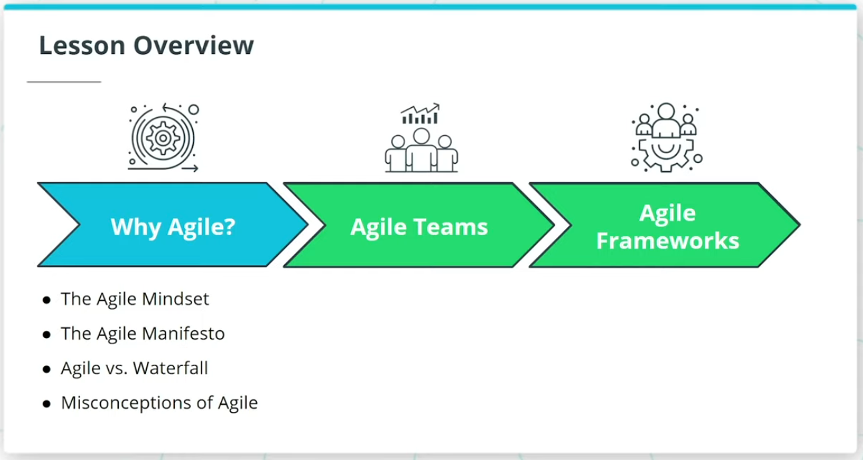

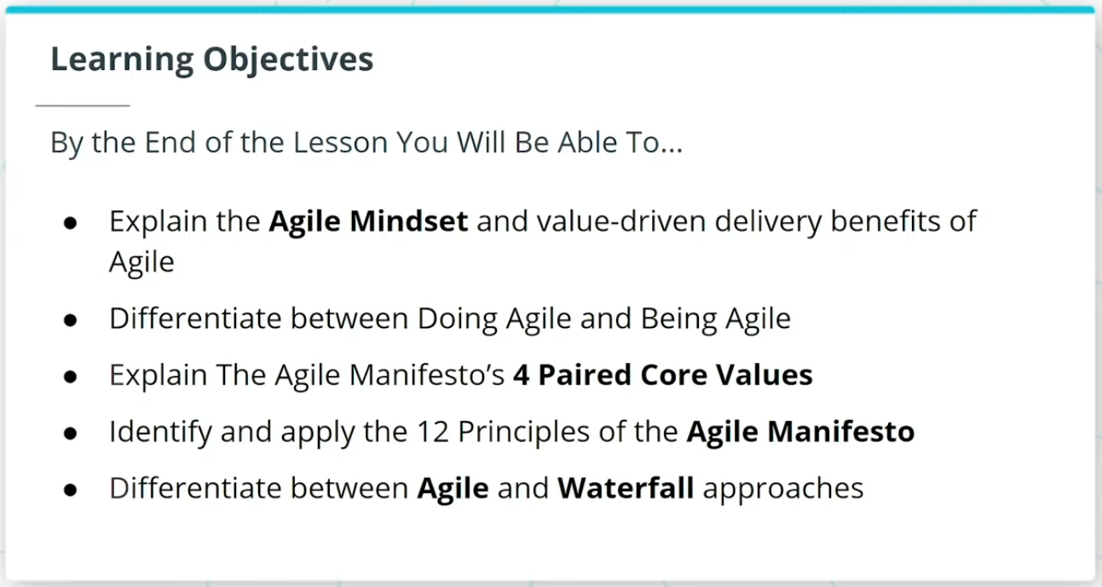

### **What We Will Cover In This Lesson**

In this lesson, we will focus on the foundational theory behind Agile. We will discuss:

* The Agile Mindset and how it sets the tone for ‘Being’ Agile versus just ‘Doing’ Agile
* The Agile Manifesto, and how it is seen as the foundational set of 4 Paired Core Values and 12 Principles that sets the foundation for all Agile Frameworks
* How Agile differs from the more traditional Waterfall approach to product development

We will wrap up the lesson with an important discussion on common misconceptions about Agile.

### **By the End of the Lesson, You Will Be Able To...**

* Explain the Agile Mindset and value-driven delivery benefits of Agile
* Differentiate between Doing Agile and Being Agile
* Explain The Agile Manifesto’s 4 Paired Core Values
* Identify and apply the 12 Principles of the Agile Manifesto
* Differentiate between Agile and Waterfall approaches

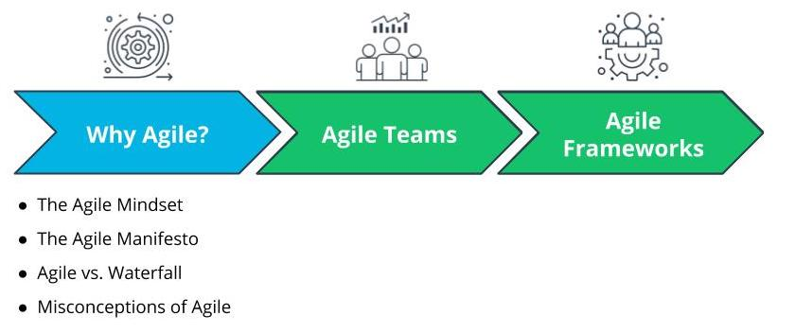

What We Will Cover In This Lesson

# Why Agile

## Why Are Organizations Adopting Agile Part 1

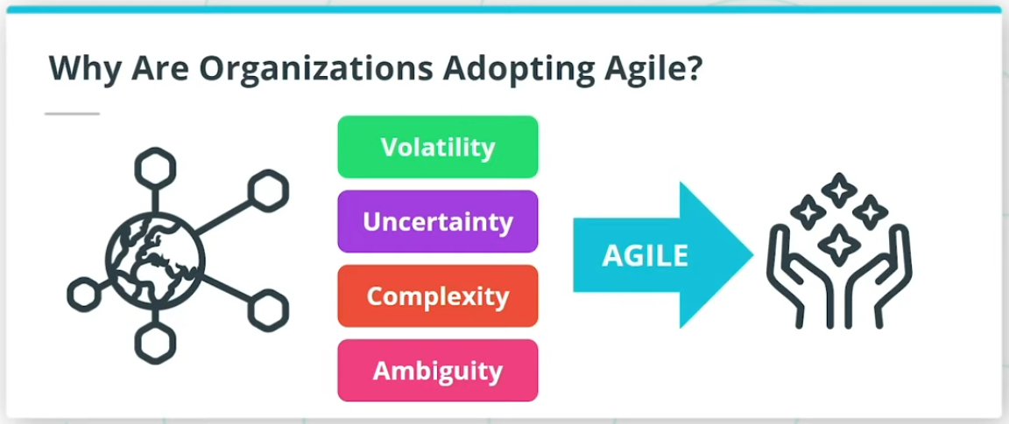

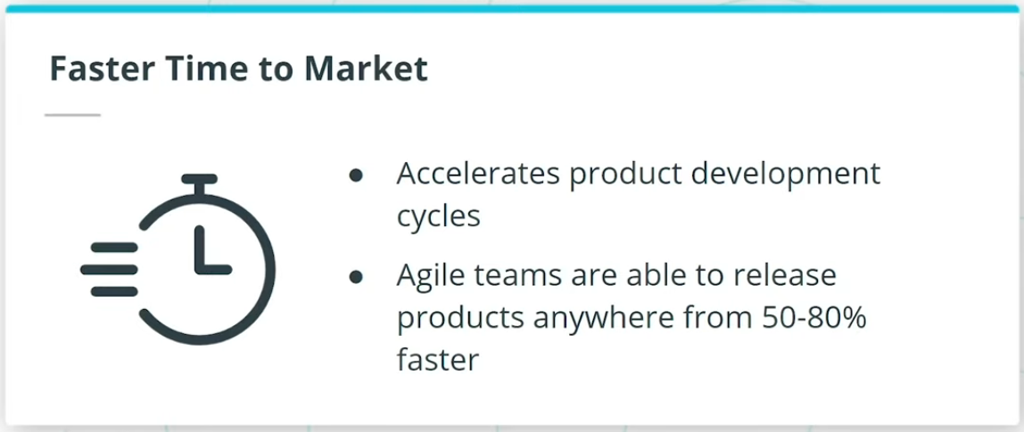

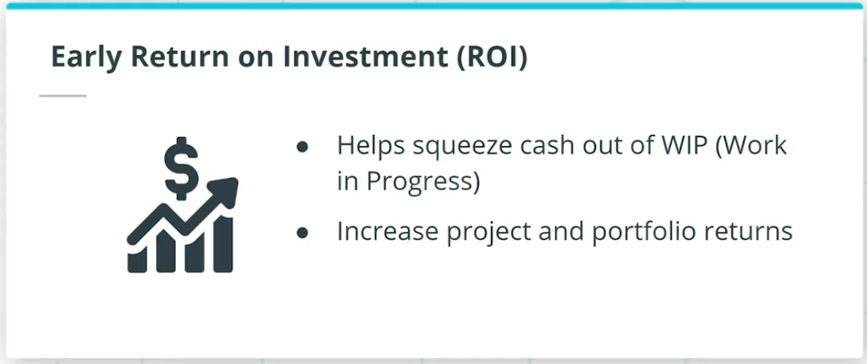

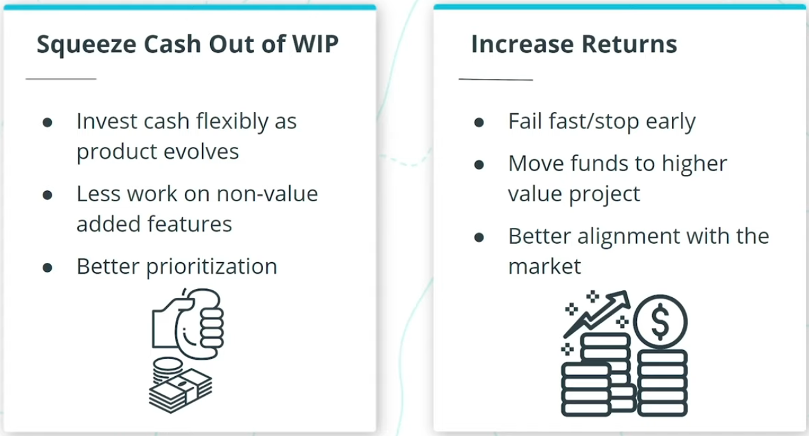

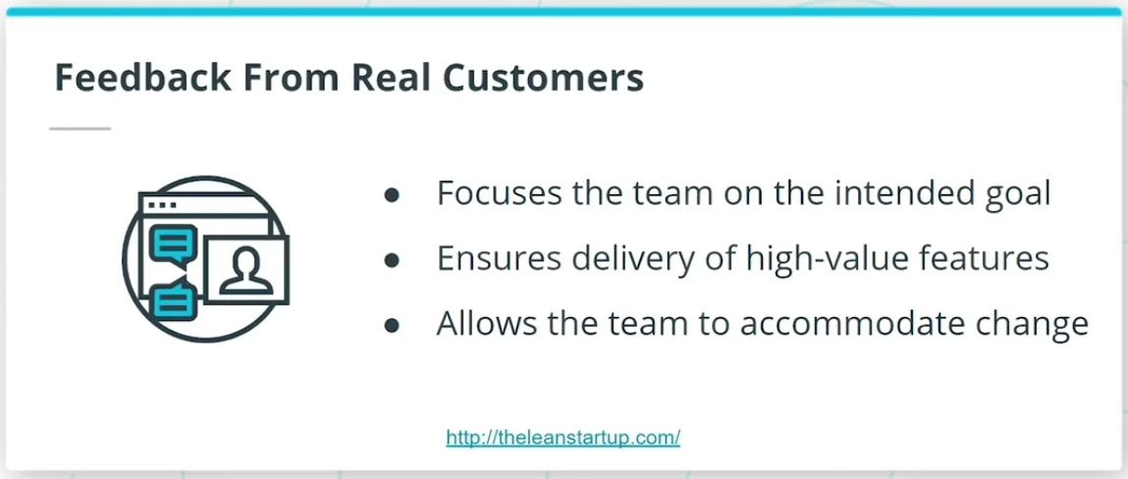

So, why are forward-thinking organizations rapidly adopting Agile? And why are we seeing that global professional bodies such as The Project Management Institute (PMI) in their PMBOK Guide and The International Institute of Business Analysis (IIBA)’s BABOK Guide, have incorporated and highlighted the importance of Agile in project management, business analysis, and other product delivery activities?

In an increasingly interconnected and competitive global marketplace, I am seeing Agile being leveraged by successful organizations across the globe to thrive in today’s digital age. Agile enables organizations to predictably deliver value in a world where we are constantly being challenged with Volatility, Uncertainty, Complexity, and Ambiguity. Organizations that I have seen go through Agile transformation have benefited from the following:

* Faster time to market
* Early ROI
* Feedback from Real Customers

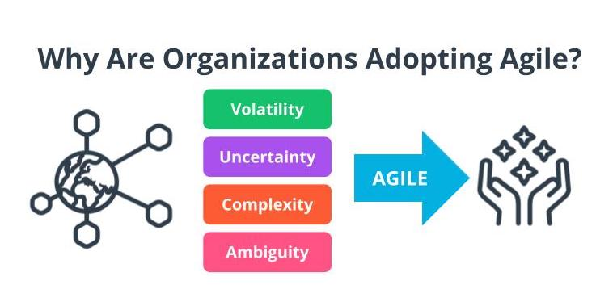

Volatility, Uncertainty, Complexity, Ambiguity

*Note: You are going to learn more about VUCA later in this lesson.*

Why Are Organizations Adopting Agile Part 2

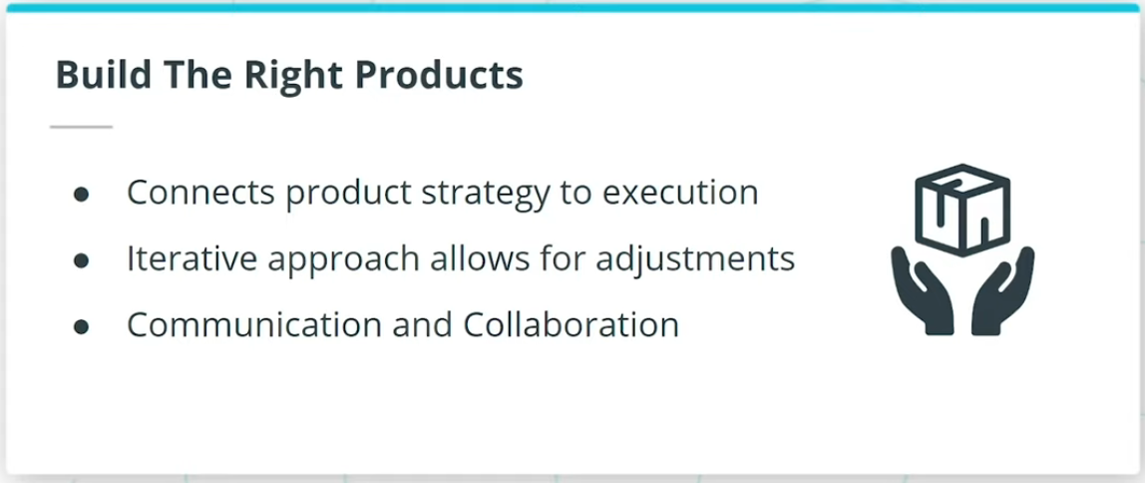

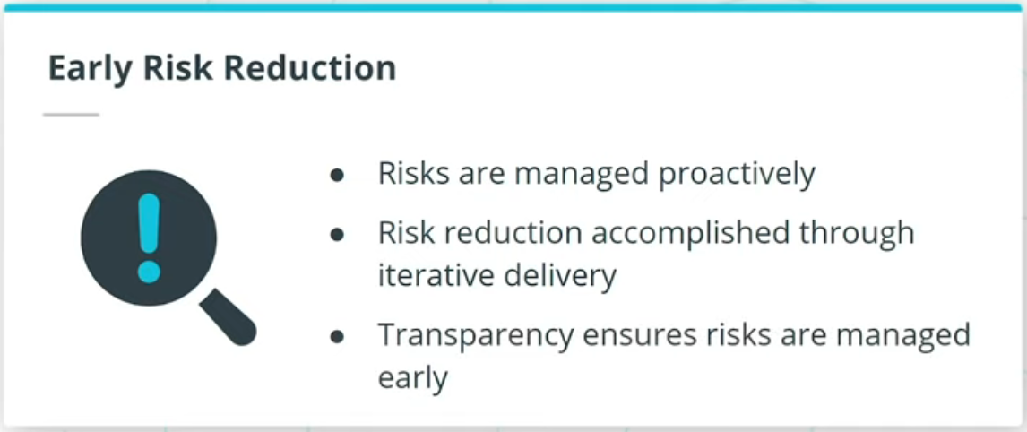

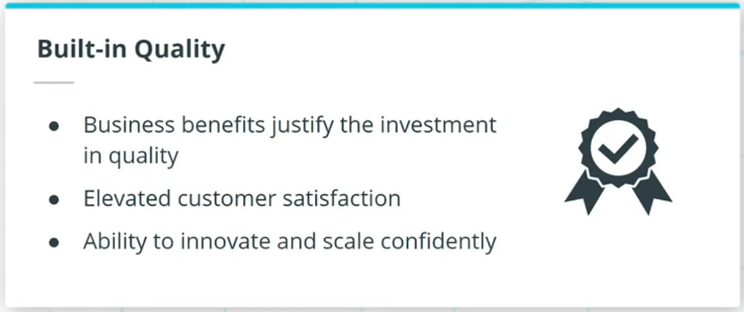

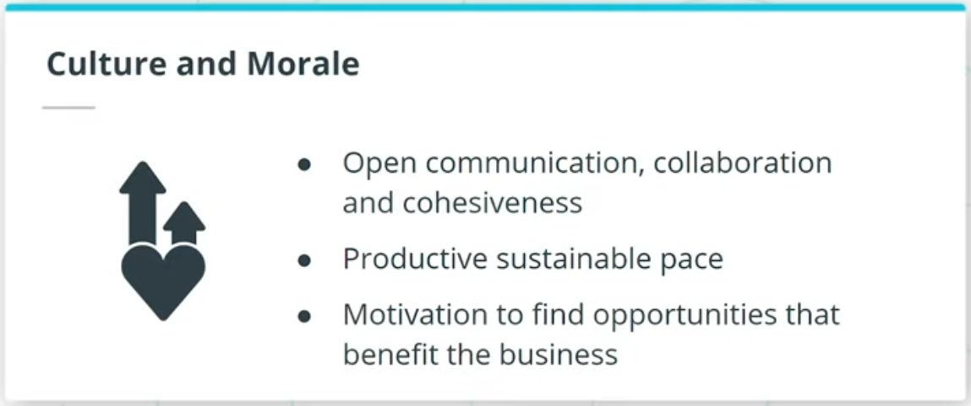

### **Organizations that go through Agile transformation have also benefited from:**

* Build the right products
* Early risk reduction
* Built-in quality
* Culture and morale

## Efficiency vs. Effectiveness

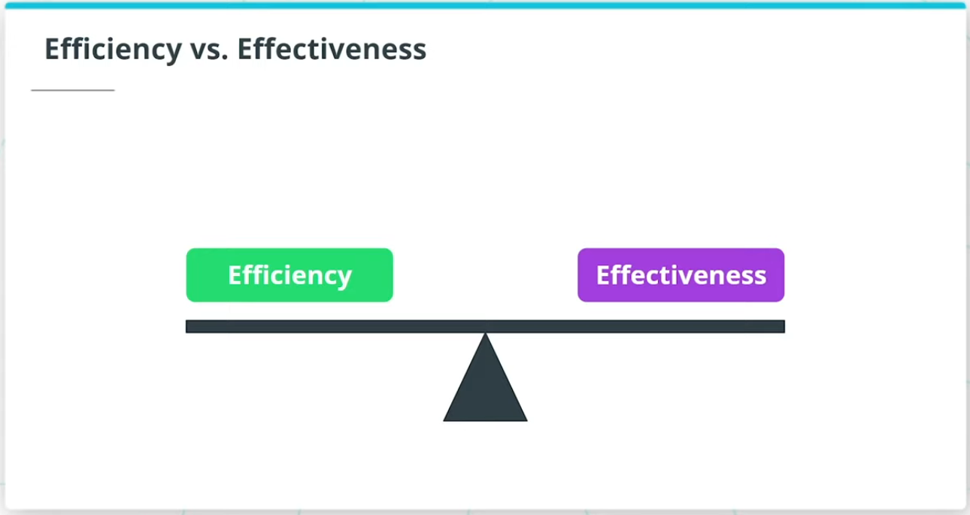

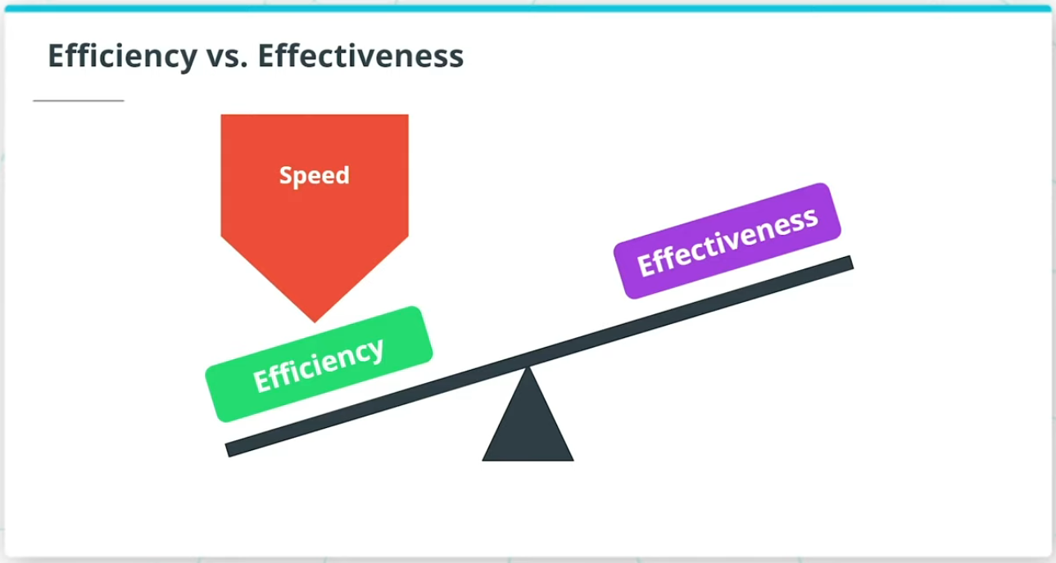

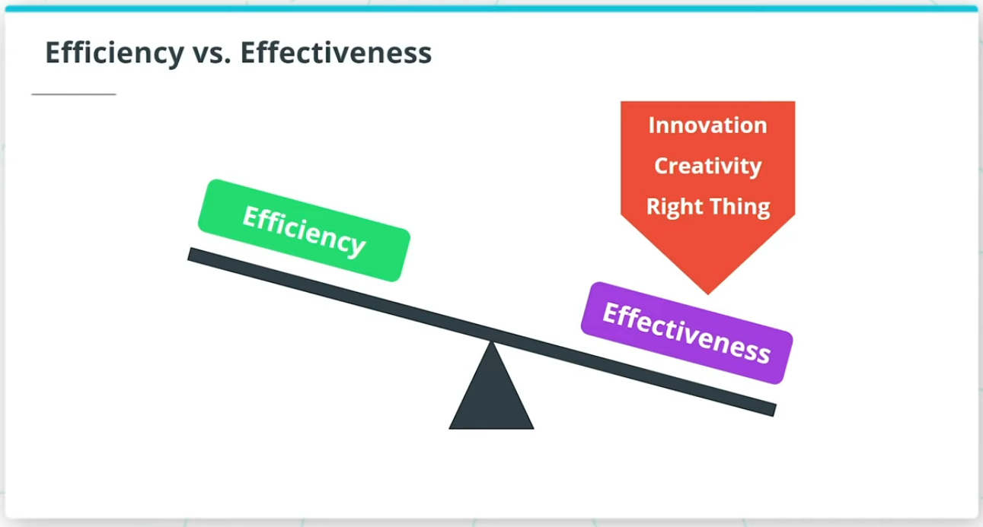

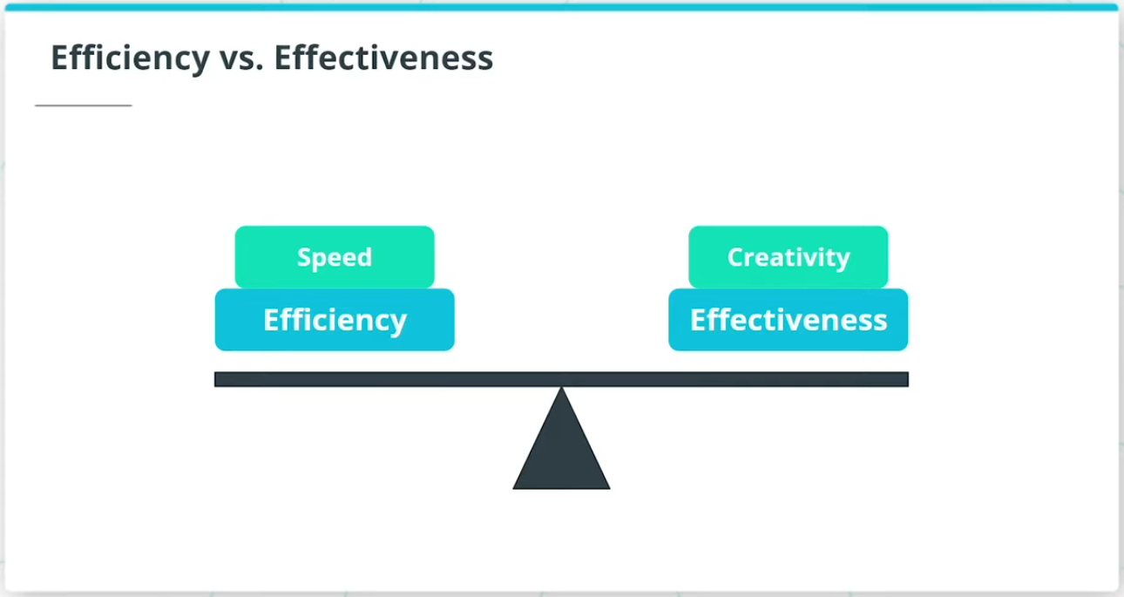

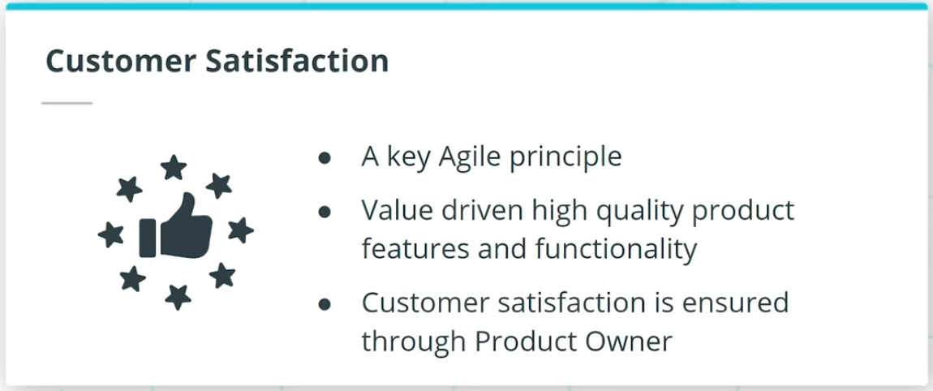

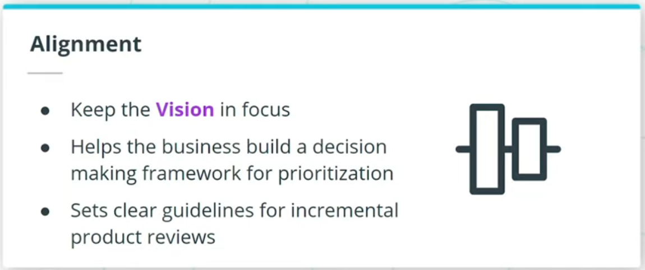

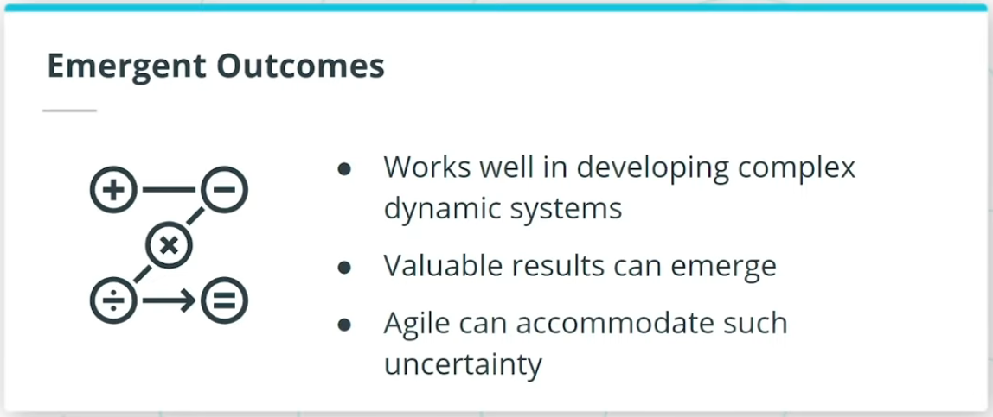

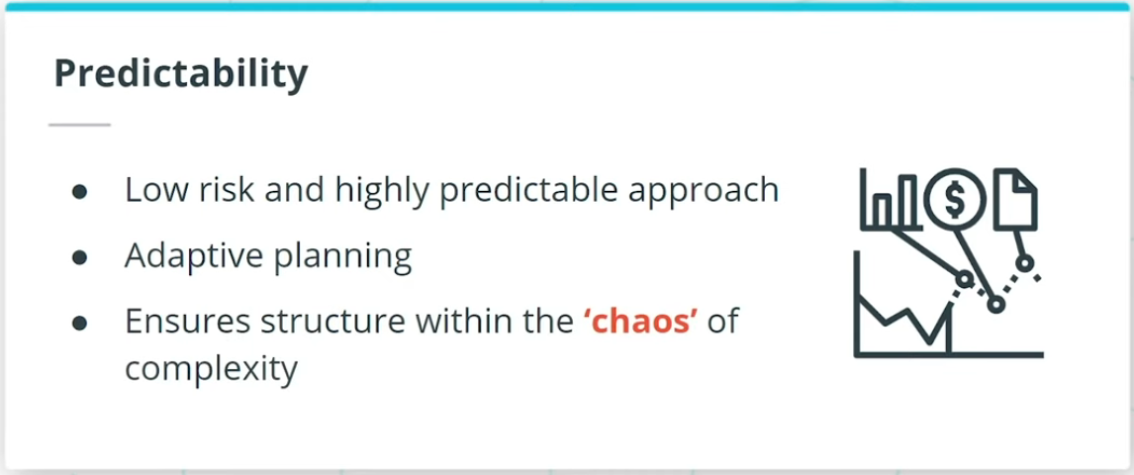

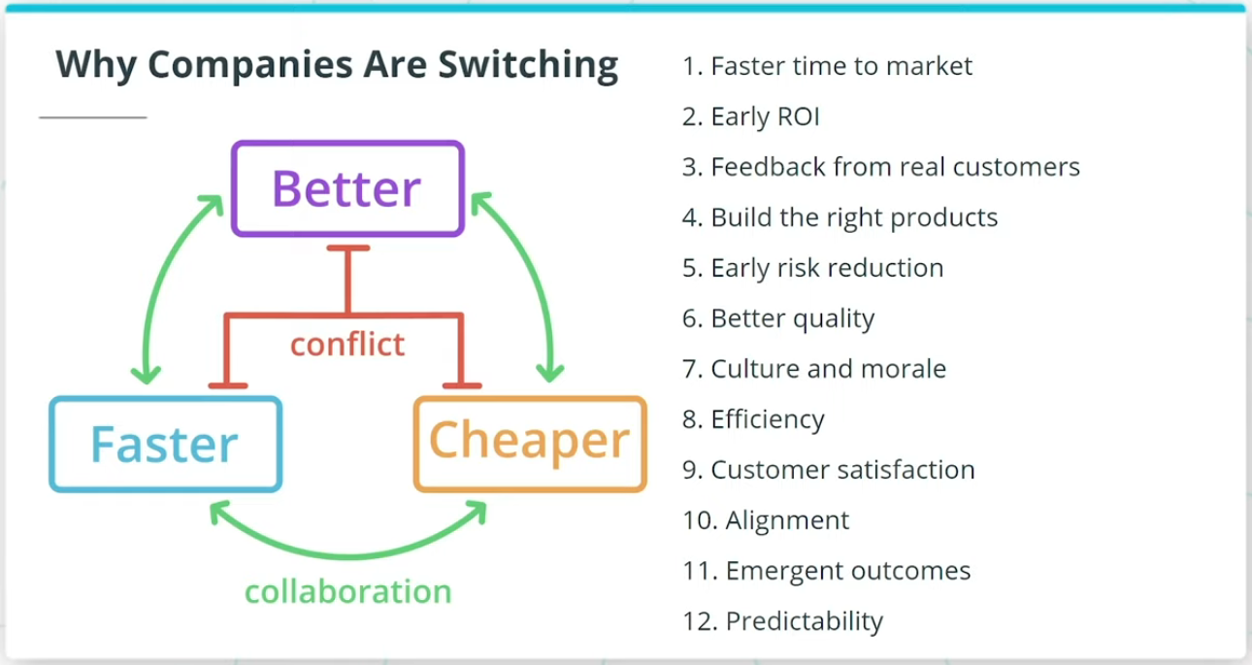

### **Efficiency and effectiveness is a fine balancing act that Agile recommends.**

If you’re only focused on going fast, you prioritize efficiency.

If you’re trying to focus on innovation, creativity, and making sure you’re working on the right thing, you need to focus on effectiveness.

This is often done at the cost of efficiency.

Agile ensures a balanced approach whereby Agile Teams ensure there is a balance between speed and creativity.

Agile transformations also benefit from:

* Customer Satisfaction
* Alignment
* Emergent Outcomes
* Predictability

Organizations want to use Agile to get there by developing products better, faster, and cheaper.

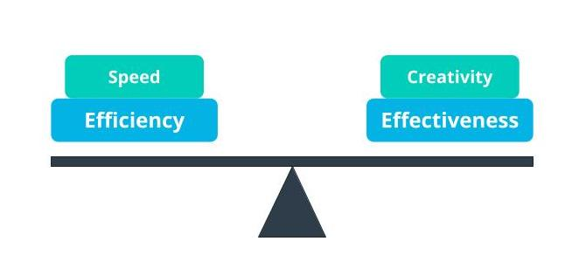

Agile Balances Efficiency And Effectiveness

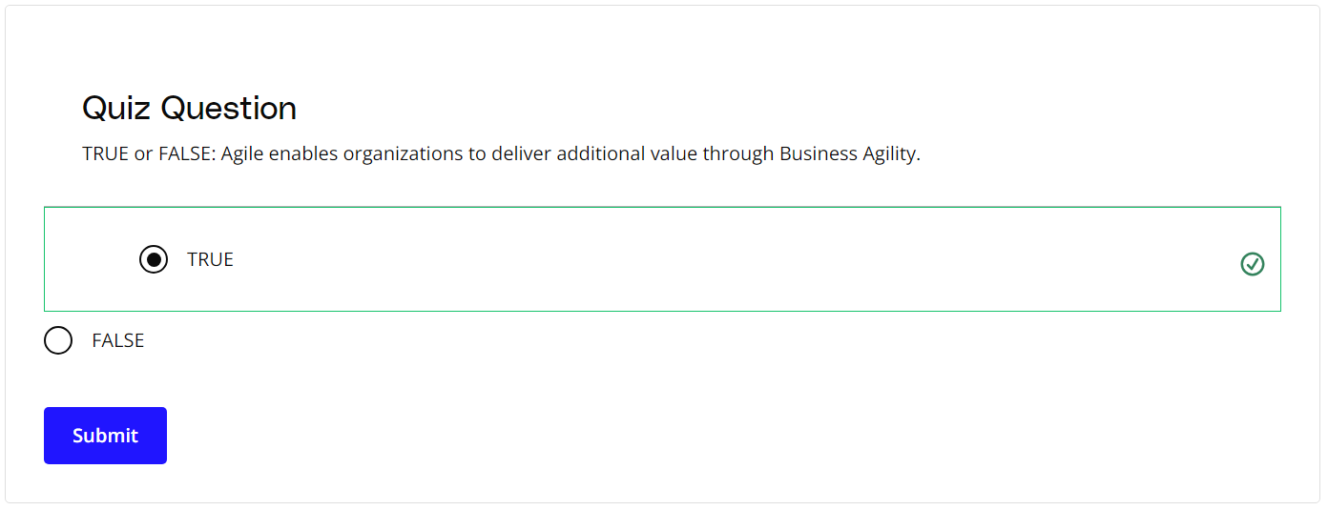

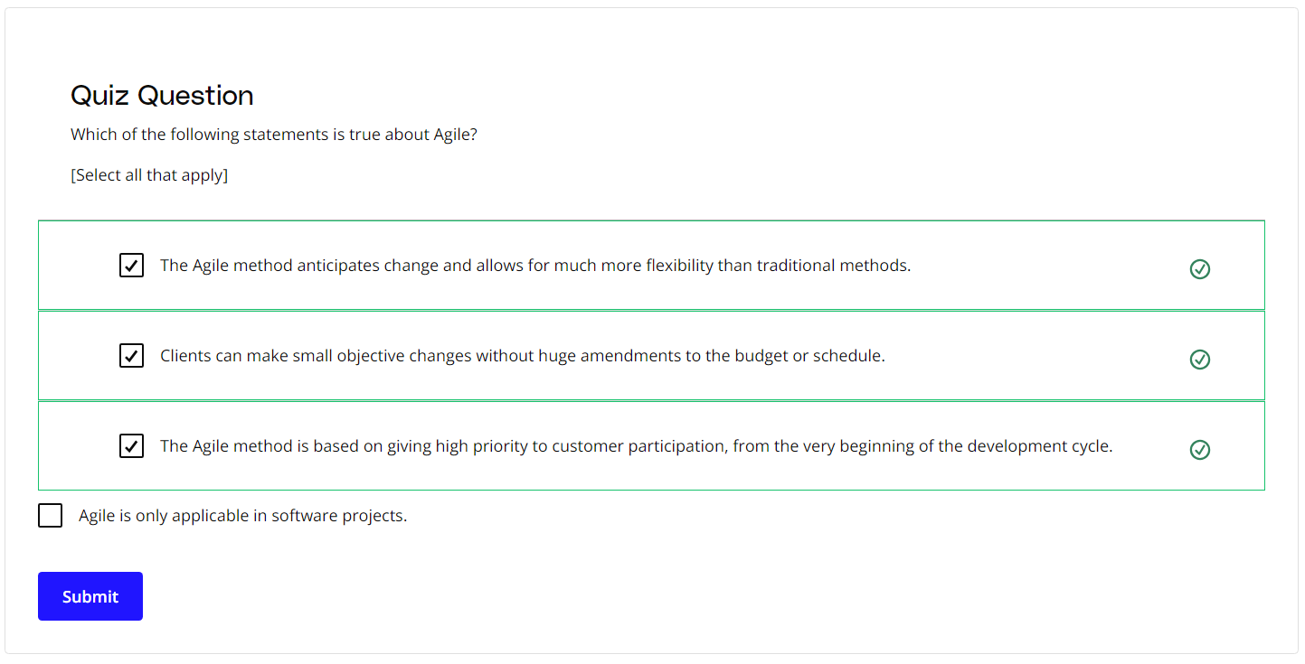

### **New Terms**

* **Ambiguity**: Ambiguity refers to a lack of clarity, such as not having a clear understanding of the genuine needs of the customer and end-users
* **Complexity**: Complexity exists when there are many interconnected parts and variables that influence each other
* **Muda**: Lean principles refer to the Japanese term Muda as waste; Agile teams focus on the removal of non-value adding tasks that are seen as Muda
* **Product Owner**: A business proxy or representative of the business users who is the Voice of the Customer (VOC)
* **Return on Investment (ROI)**: Return on investment (ROI) is calculated as the ratio between net profit and cost of investment over a defined period of time
* **Uncertainty**: The extent to which an organization can confidently predict or forecast the future; more uncertainty makes it harder to predict
* **Voice of the Customer**: A term used to articulate the steps to capture customer's needs
* **Volatility**: Volatility is when there are unexpected or unstable possibilities that may influence the work being done
* **VUCA**: Volatility, Uncertainty, Complexity, Ambiguity
* **WIP (Work in Progress)**: The work that has been started but not yet completed

### **Additional Resources**

* [**The Lean Startup**](http://theleanstartup.com/) by Eric Ries

# How Experts Approach Agile

## Thinking About Agile

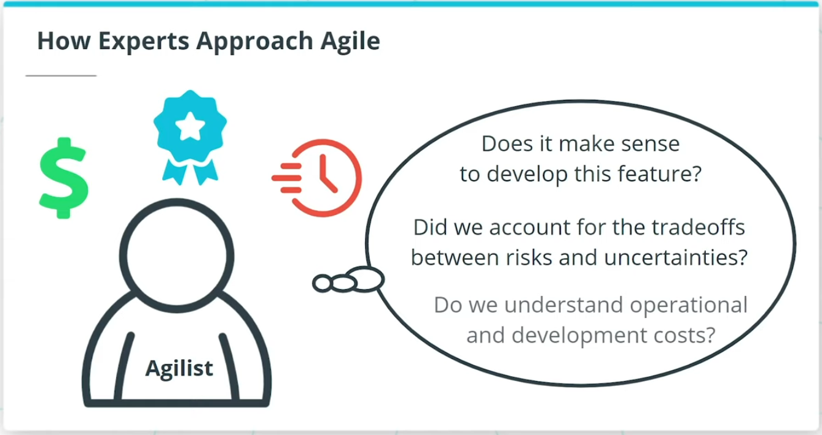

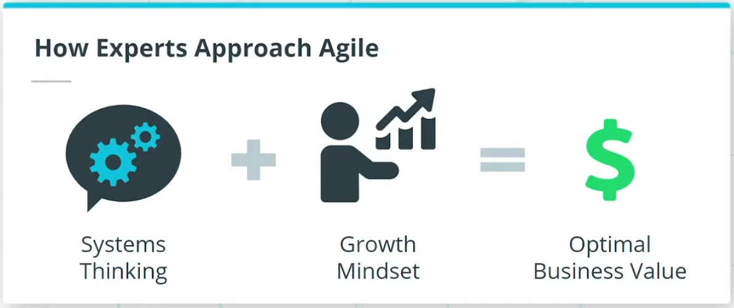

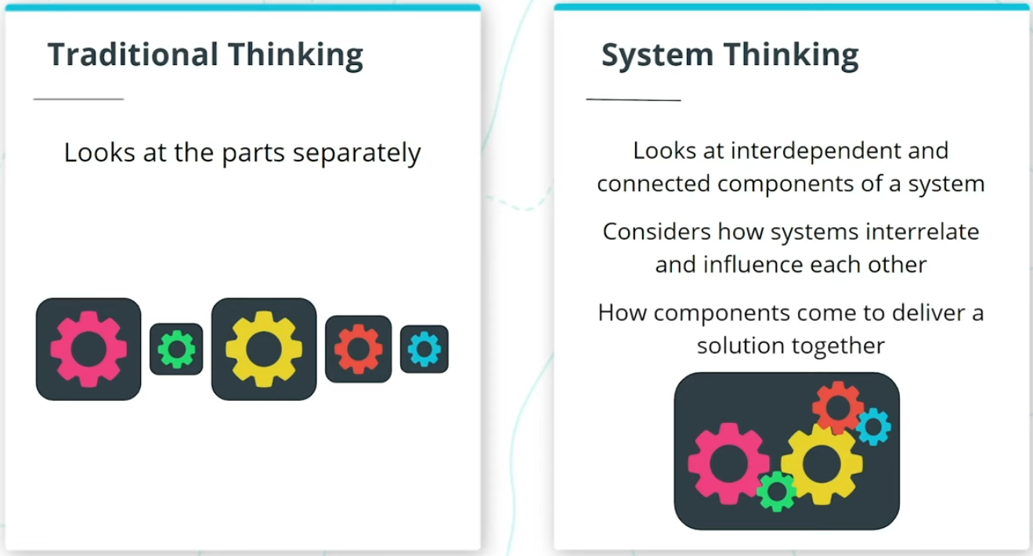

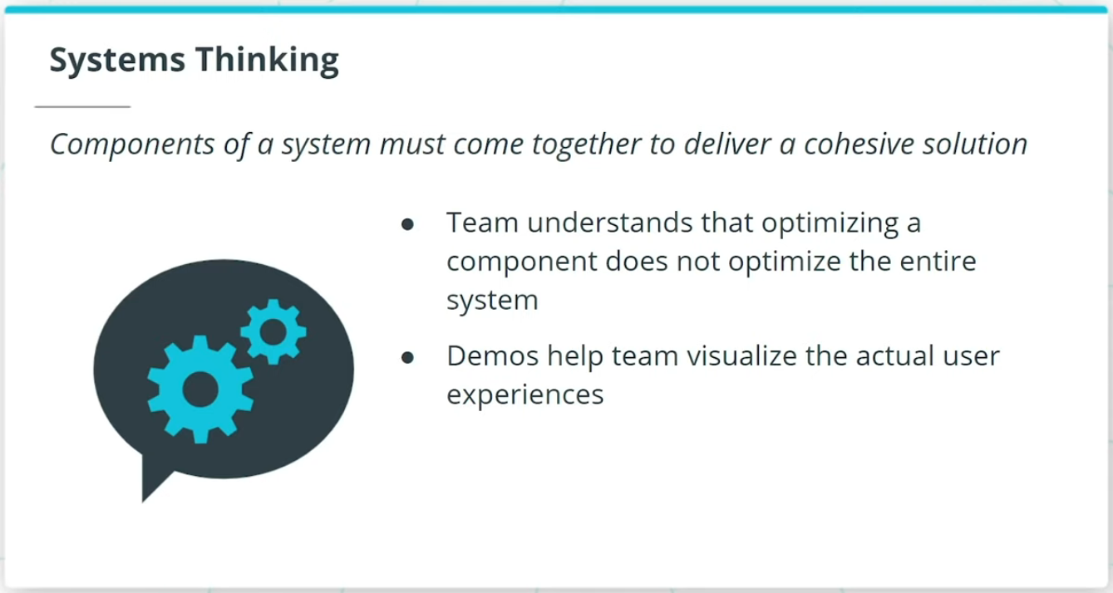

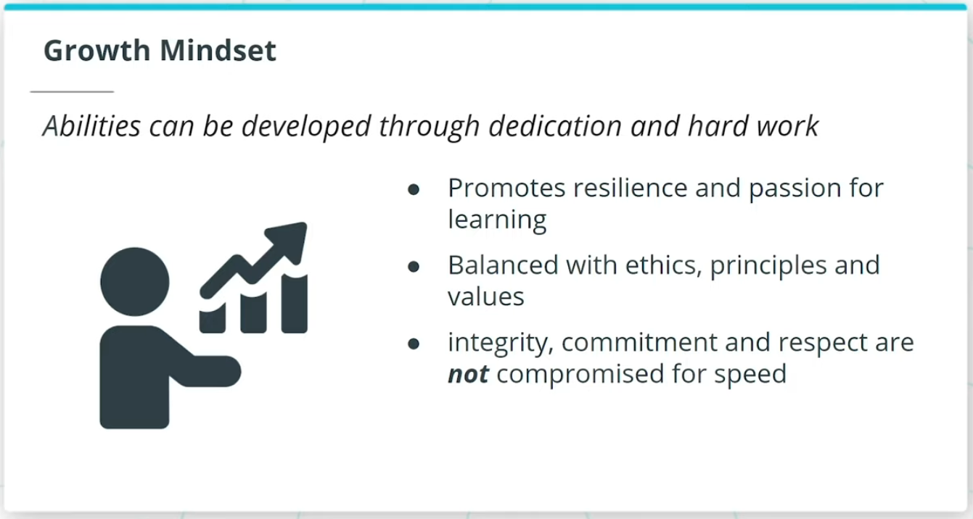

### **Agile Is Based on a Systems Thinking Approach and a Growth Mindset**

* Agilists adopt a practical and realistic approach to delivering the best value, and quality, in the shortest sustainable time.
* A Systems Thinking approach, reinforced by a Growth Mindset, helps Agile experts deliver optimal business value.
* Systems thinking takes a holistic approach in which the Agile Team looks at the way a system's components interrelate and influence each other and how these components come together within the context of larger systems to deliver a solution.
* In a growth mindset, individuals on a team have the mindset that their abilities can grow through dedication and hard work.

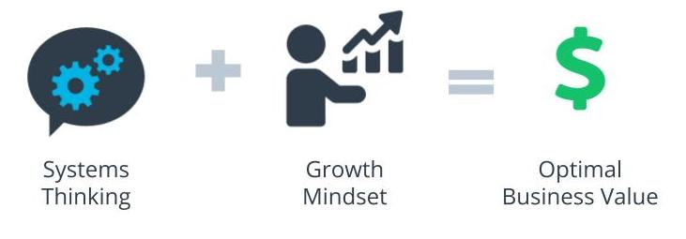

Systems Thinking + Growth Mindset = Optimal Business Value

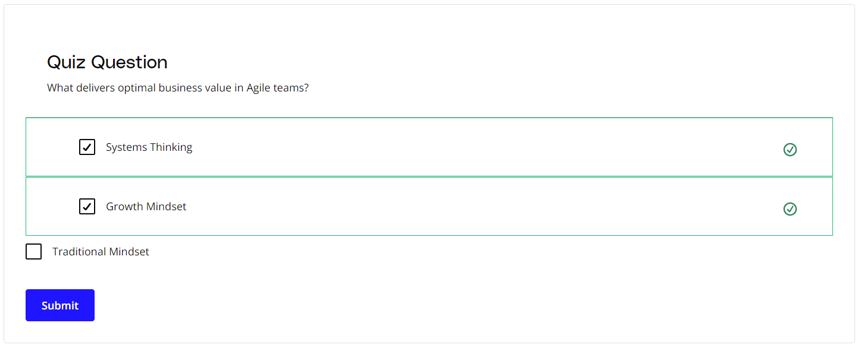

### **New Terms**

* **Growth Mindset**: The mindset that an individual's abilities can grow through dedication and hard work
* **Systems Thinking**: A holistic approach that looks at the way a system's components interrelate and influence each other and how these components come together within the context of larger systems to deliver a solution

### **Additional Resources**

* Brad Smith and Carol Ann Browne. ***Tools and Weapons: The Promise and the Peril of the Digital Age***. Penguin, 2019.  
  In this book, Brad Smith and Carol Ann Browne share how one of the world's largest and most powerful companies leverages Agile practices to overcome today's challenges in the global marketplace.